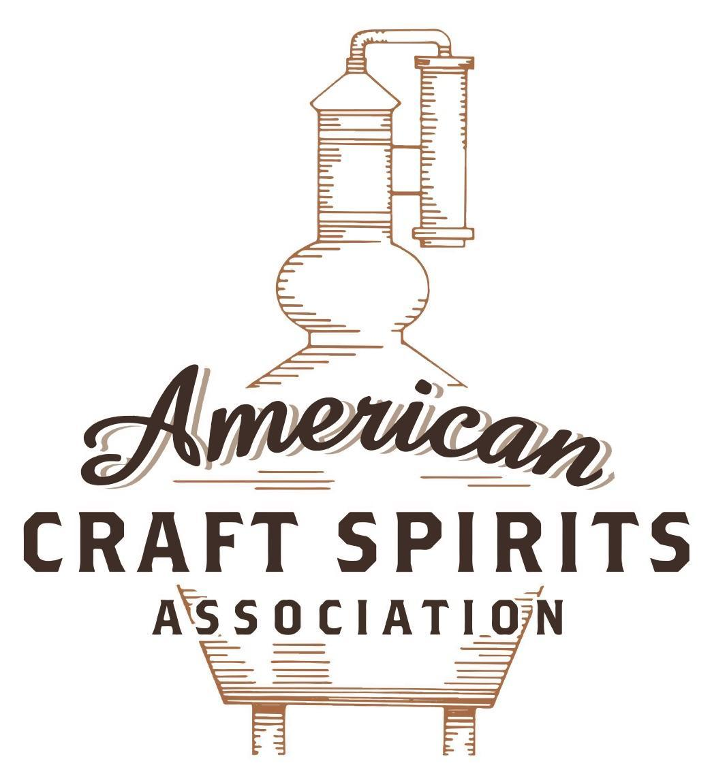
Spirits DtC Shipping Guide

This guide summarizes the direct-to-consumer shipping rules for distilleries in all 50 states and D.C. and also addresses the measures state governments have taken to ease delivery and shipping restrictions during the COVID-19 pandemic.

DtC Quick Guide Comparison

Out-of-State Distilleries  Can Ship Into State? |  |  |  | In-State Distilleries  Can Ship Within State?
State | Yes | No |  | State | Yes | No
AL |  | X |  | AL |  | X
AK | X |  |  | AK | X
AZ | X |  |  | AZ | X
AR |  | X |  | AR |  | X
CA |  | X* |  | CA |  | X*
CO |  | X |  | CO |  | X
CT |  | X* |  | CT |  | X
DE |  | X |  | DE |  | X
DC | X |  |  | DC | X
FL |  | X |  | FL |  | X
GA |  | X |  | GA |  | X
HI |  | X* |  | HI |  | ?*
ID |  | X |  | ID |  | X
IL |  | X* |  | IL |  | X*
IN |  | X |  | IN |  | X
IA |  | X* |  | IA |  | X*
KS |  | X |  | KS |  | X
KY | X |  |  | KY | X
LA |  | X |  | LA |  | X
ME |  | X* |  | ME |  | X*
MD |  | X |  | MD |  | X
MA |  | X |  | MA |  | X
MI |  | X |  | MI |  | X
MN |  | X |  | MN |  | X
MS |  | X |  | MS |  | X
MO |  | X |  | MO |  | X
MT |  | X |  | MT |  | X
NE | X |  |  | NE | X
NV |  | X* |  | NV |  | X
NH | X |  |  | NH |  | X*
NJ |  | X* |  | NJ |  | X*
NM |  | X |  | NM |  | X
NY |  | X* |  | NY |  | X*
NC |  | X |  | NC |  | X
ND | X |  |  | ND | X
OH |  | X |  | OH |  | X
OK |  | X |  | OK |  | X
OR |  | X |  | OR | X
PA |  | X* |  | PA |  | X
RI |  | X* |  | RI |  | X
SC |  | X |  | SC |  | X
SD |  | X |  | SD |  | X
TN |  | X |  | TN |  | X
TX |  | X |  | TX |  | X
UT |  | X |  | UT |  | X
VT |  | X |  | VT |  | X
VA |  | X |  | VA |  | X
WA |  | X* |  | WA | X
WV |  | X* |  | WV |  | X*

WI |  | X |  | WI |  | X
WY |  | X |  | WY |  | X

Notes:
*CA: If passed and signed into law, Senate Bill 620 would allow licensed distilled spirits producers in states other than California and licensed distilled spirits manufacturers or craft distillers in California who obtain distilled spirits direct shipper permits to ship directly to consumers in California
*CT: Consumers with appropriate permit may receive alcohol shipments
*HI: Consumers with appropriate permit may receive alcohol shipments; If passed and signed into law, Senate Bill 65 would allow licensed distilled spirits manufacturers in Hawaii and in states other than Hawaii who obtain direct shipper permits to ship directly to consumers in Hawaii
*IL: If passed and signed into law, Senate Bill 0532 would allow licensed distilled spirits producers in Illinois and in states other than Illinois who obtain distillery shippers’ licenses to ship directly to consumers in Illinois
*IA: If passed and signed into law, House File 639 would allow native distilled spirits manufacturers in Iowa and in states other than Iowa who obtain direct shipper permits to ship directly to consumers in Iowa and to consumers in states other than Iowa
*ME: If passed and signed into law, Legislative Document 1358 would allow distilleries outside of Maine with current manufacturer licenses and distilleries licensed in Maine who obtain spirits direct shipper licenses to ship directly to consumers in Maine
*NJ: (1) If passed and signed into law, Assembly Bill 3167 would allow a craft distillery licensees to ship no more than 9 liters of distilled spirits to a consumer in New Jersey; (2) If passed and signed into law, Senate Bill 3020 would allow craft distillery licensees in New Jersey or in states other than New Jersey to ship no more than 20 liters of distilled spirits to a consumer in New Jersey via common carrier
*NV: Licensed individuals can import one gallon per month of spirits for personal use and the out-of-state supplier must pay excise tax
*NH: If passed and signed into law, Senate Bill 125 would allow licensed liquor manufacturers who obtain direct to consumer shipping permits from the commission to ship directly to consumers in New Hampshire
*NY: Consumer may import up to 90L of liquor per year for personal use without a license; If passed and signed into law, Assembly Bill 3275 would allow licensed liquor manufacturers in states other than New York and licensed distillers and farm distillers in New York to ship no more than thirty-six cases (no more than nine liters per case) of liquor to consumers in New York
*PA: Consumer may place a special liquor order and distiller must ship to a PLCB-operated store
*RI: Distiller can only ship to customer if order was personally placed by customer at distiller's premises
*WA: If passed and signed into law, House Bill 1432 would allow licensed spirits manufacturers in states other than Washington to ship spirits to consumers in Washington
*WV: Distilleries, mini-distilleries, or micro-distilleries licensed in West Virginia or a state other than West Virginia who obtain private direct shipper licenses to ship to a consumer in West Virginia, however the shipments must be made to a retail liquor outlet

DELAWARE
Shipment Outbound – Yes, if the sale and shipment is allowed by the applicable state and local laws (4 Del. C. § 104; § 512E).
Shipment Inbound – No, direct shipper license only available for beer and wine. Furthermore, direct shippers must deliver the wine and beer by common carrier to a Delaware wholesaler, who will in turn deliver the shipment to a DE off-premises retail license, who may then deliver to a resident (4 Del. C. § 526; § 701).
Shipment Intra-state – No, in-state craft distillers can only sell spirits on the premises by the bottle or by the glass for consumption on or off the premises. Off-premises sales must be limited to a maximum of 1 case (i.e., not more than 12-750 ml bottles) per day to each retail customer for consumption off the premises (4 Del. C. § 512E).
COVID-19 Measures – During the state of emergency, entities with a license to sell off-premise (including craft distilleries) can take a customer’s order either by phone or email and can then bring a product to a customer’s vehicle in the immediate parking lot or curb. Delaware’s state of emergency was terminated on July 13, 2021.
Commissioner Guidelines Link: https://date.delaware.gov/OABCC/OABC%20Commissioner%20Guidelines.pdf
Termination of State of Emergency Link: https://governor.delaware.gov/wp-content/uploads/sites/24/2021/07/Termination-State-of-Emergency-07122021.pdf
Citation (shipment)
Delaware Code
4 Del. C. § 104 Sale or shipment out of State.
(a) No sale of alcoholic liquor shall be made to a person in a state or a division of a state where such sale is prohibited by law.
(b) No shipment of alcoholic liquor shall be made into a state or into a division of a state where such shipment is prohibited by law.
Link: https://delcode.delaware.gov/title4/c001/index.html#104.
4 Del. C. § 512E Craft distillery.
(c) Notwithstanding any provision of this title to the contrary, a craft distillery license shall allow the licensee:
(3) To sell, deliver, and ship such spirits in labeled barrels, bottles or other closed containers to persons licensed under the provisions of this title to import spirits; and to sell and ship spirits to persons outside of the State in accordance with this title;
(4) To store and sell spirits on the premises by the bottle or by the glass for consumption on or off the premises where sold; and to purchase alcoholic beverages from licensed Delaware importers or retailers to add to product manufactured by the craft distillery to sell to patrons for on premises consumption only. The amount of spirits sold for off-premises consumption shall be limited to a maximum of 1 case (i.e., not more than 12-750 ml bottles) per day to each retail customer for consumption off the premises…
Link: https://delcode.delaware.gov/title4/c005/sc02/index.shtml
4 Del. C. § 526 Direct purchasing of wine and beer.
(a) Notwithstanding any other provision in this title, a natural person who is a Delaware resident may purchase sparkling wine, still wine and beer that is not readily available to consumers throughout the State directly from a manufacturer or retailer of such beverages domiciled outside of Delaware…
(e) Under no circumstance may the wine or beer be shipped directly to the resident. Direct shippers must deliver the wine and beer by common carrier to a Delaware wholesaler, who will in turn deliver the shipment to a holder of a Delaware off-premises retail license. The retail licensee must then deliver the wine or beer to the resident in a manner consistent with this title and as set forth by Commissioner rules. The direct shipper shall pay a handling fee in the amount of $4 dollars per case or partial case of wine and $2 dollars per case or partial case of beer to the wholesaler who receives the shipment on behalf of the Delaware resident. The wholesaler shall then remit to the retail licensee one-half of the total handling fee.
Link: https://delcode.delaware.gov/title4/c005/sc02/
4 Del. C. § 701 Persons authorized to make sale and delivery of alcoholic liquors.
(a) No sale and delivery of alcoholic liquor shall be made in this State unless by a manufacturer or other person who holds a license of the Commissioner to sell and deliver alcoholic liquor and unless the sale and delivery is made to a person who is authorized to receive alcoholic liquor under Chapter 5 of this title.
(b) No common carrier shall be held responsible for the delivery of alcoholic liquor forbidden by this section.
(c) The Commissioner shall permit the holders of a license under §§ 531-533 of this title to receive or pick up beer in the barrel or keg directly from a manufacturer, importer or any other person authorized by this title to sell and deliver alcoholic liquor, notwithstanding any provisions of this title to the contrary.
(d) The Commissioner may permit an off-site caterer to transport alcoholic liquor in accordance with the Commissioner’s rules.
Link: https://delcode.delaware.gov/title4/c007/index.shtml

The American Craft Spirits Association (ACSA) is working diligently to give our members and industry partners relevant, current updates on statutes and regulations impacting production, sale and distribution of spirits. With the declaration of the novel coronavirus (COVID-19) in early 2020, many states have issued temporary policy changes or longer-term modernization of alcohol beverage laws. State statutes, regulations created by the state alcohol regulatory authority, as well as any other relevant guidance provided by such authorities (such as advisories, opinions, bulletins, etc.) were reviewed in creation of this document. No city or county ordinances were reviewed. Distillers should be aware that even in states where direct shipping is permissible, always remember to avoid shipping to dry counties. Please consult with your state guild or alcohol beverage authority for the most up-to-date information. This content is intended for educational and informational purposes only. ACSA's pro bono law firm of Malkin Law P.A. provided the core content found in this comprehensive overview of the spirits distribution after COVID-19. It was completed in August 2021 and will be updated regularly. If you have updates you would like to provide, please send to legislation@americancraftspirits.org or directly to the law firm at: ryan@malkin.law / malkin.law. Thank you.

